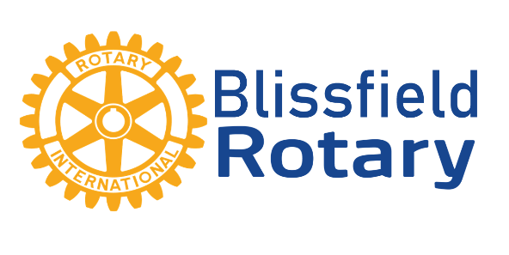

Dear Friend of the Blissfield Rotary Club,
We are excited to announce the details of the 32nd annual Blissfield Rotary Club Auction presented by A and B Railroad! This event will take place on Saturday, March 28, 2020 at the Adrian Armory and Event Center starting at 5:30pm. Jerry Anderson will be returning as our celebrity auctioneer. This magical evening will include cocktails, appetizers, dinner, and dessert. The event features a silent auction, live auction, and various games to participate in!

The Blissfield Rotary Club is committed to service to others, our community, and promoting literacy around the globe. To achieve our mission, we seek sponsorship and donations from businesses in our community that share our passion for helping others. The following are some highlights of what we have achieved over the years with the help of your generous sponsorships:

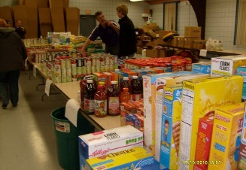
- Annual Halloween Bonfire with activities for children a local tradition since 1938
- $50,000 to Blissfield Elementary Schools for the BELL lab
- $30,000 in renovations to the Bliss-Liewert Senior Center
- Construction of an electronic sign to inform citizens of community events
- Food to thousands of people in Lenawee County and Haiti through partnerships with Knights of Columbus and I-92 Ministries
- Hurricane relief to thousands of families through Hope and Encouragement for Humanity (HEH)
- Diesel ambulance purchase in India
- Dental care in Nicaragua
- $5,000 towards a truck to Hut Outreach serving in Haiti
- Fire truck, two ambulances, and equipment to Puerto Vallarta
- In-home water filtration systems for families in Mexico

This year’s auction proceeds will be devoted to supporting our Blissfield walking trails project as well as international projects. We are hopeful that you will join us at the auction and/or consider sponsorship or donating to our endeavors this year!

Thank you, in advance, for your generosity. We hope to see you at the Auction!

Blissfield Rotary Club

For answers, tickets, or sponsorship opportunities, please contact:
Daniel Bailey 517.486.1232 danbaileydc@yahoo.com -or-
Jakob Norment 517.745.8275 jakobnorment24@live.com
Corporate table inquiries – Chris Mallow 517.486.3379 mallowdds@hotmail.com
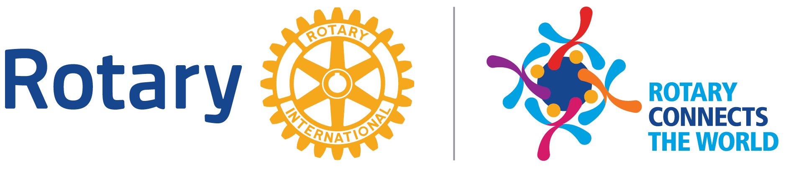

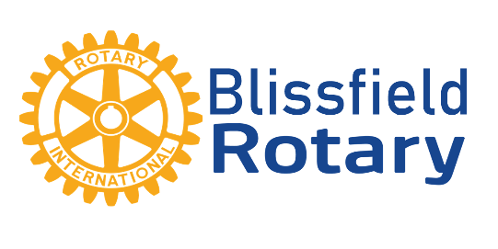

Blissfield Rotary Charity Auction
presented by A and B Railroad
2020 Sponsorship Opportunities

Presenting Sponsor (exclusive) – $10,000 *Unavailable this year - retained by A&B Railroad!*
- ‘Presenting Sponsor’ company name & logo included in all advertisements
- Logo on social media ad campaign with a target audience of 98,000 people
- Special recognition from Jerry Anderson throughout the live auction
- Special recognition from the Club President during the event
- Logo prominently featured in the program
- Logo prominently featured on the main stage banner
- Featured plaque on a bench along the walking trail in the park
- Recognition on our Facebook page
- Recognition throughout area Rotary Members (28,000 members)
- Two reserved corporate tables with seating for 16 guests
- Right to retain presenting sponsorship on 1 year continuum

Platinum Sponsor – $5,000
- Special recognition from the Club President during the event
- Logo prominently featured in the program
- Logo featured on the main stage banner
- Featured plaque on a bench along the walking trail in the park
- Recognition on our Facebook page
- Recognition throughout area Rotary Members (28,000 members)
- Two reserved corporate tables with seating for 16 guests

Gold Sponsor – $1,500
- Recognition on our Facebook page
- Logo featured in program
- Recognition from the Club President during the event
- Two reserved corporate tables with seating for 16 guest

Corporate Table – $600
- Corporate logo displayed in program
- One reserved table with seating for 8 guests

Auction Items
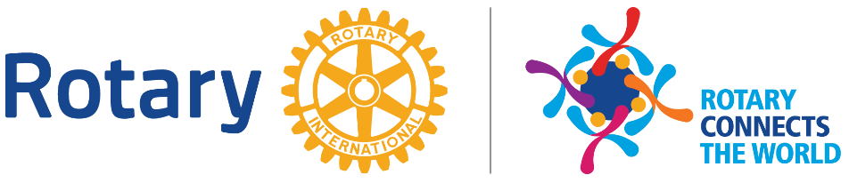
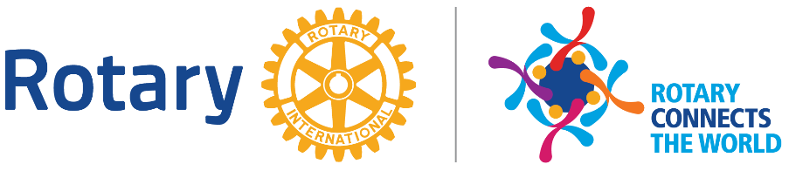
- We are always appreciative of items to be auctioned. Our silent auction items range in value from $50 to $500 per item. Our live auction items often bring in upwards of $500

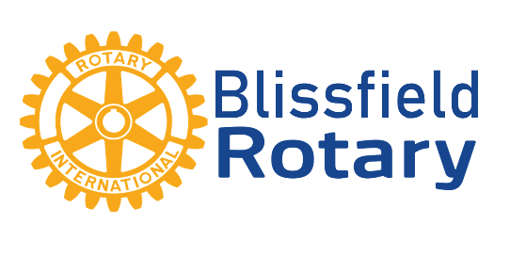

Our company would like to support the work of the Blissfield Rotary Club by serving as a:

____ Platinum Sponsor ($5,000)

____ Gold Sponsor ($1,500)

____ Corporate Sponsor ($600)

We would like to provide:

____ Auction Item

____ Monetary donation to procure “Want list” items to be auctioned

Sponsor Information:

Corporate Name:_______________________________________________________________

Contact Name:_________________________________________________________________

Email:__________________________________________ Phone:________________________

I would like to purchase ____ additional tickets at a price of $75 each for a total of $_______

You may provide names for seating purposes at a later date or email Chris Mallow at mallowdds@yahoo.com when known

Please make checks payable to Blissfield Rotary and mail to PO Box 4, Blissfield, MI 49228

